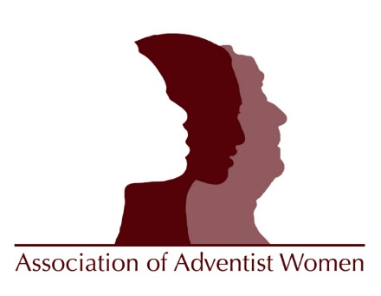
Woman of the Year Award (WOYA) 2020 Nomination Form
Send Nomination Material to: Deadline for Entries: August 1, 2020
Linda Becker
7409 Exbury Rd.
Lincoln, NE 68516
Email: linda.becker@ucollege.edu

Please provide the following materials:
1. A Filled out copy of the form that follows.
2. Nominee’s curriculum vita or résumé.
3. A biographical sketch that will provide judges with a personal sense of your nominee. Include activities, accomplishments, and personal qualities that make this woman outstanding in the areas of the criteria for the award for which you are nominating them. Discuss participation in professional, community, and church organizations or boards. If there are factors in coping with unusual circumstances, they should be noted. Verify that the information is accurate, pertinent, and complete.
4. Letters of reference (preferably four), including one from her pastor must accompany this entry form. Letters must include the address and signature of each reference.
5. Name and address of the SDA church of which your nominee is a member, including the name and phone number of the pastor.
NOTE: Materials cannot be returned. Nominations must include all of the above information to be eligible for the AAW Woman-of-the-Year Award (WOYA). The awards will be presented at the banquet to be held at the national conference of the Association of Adventist Women in October, 2020. It is not yet clear if this will be a virtual or actual banquet.
To seek clarifications, e-mail linda.becker@ucollege.edu

Woman of the Year Award (WOYA) 2020 Nomination Form

Category of Service Awards (Circle One)
Family Life Lifetime Achievement
Professional Life Outstanding Achievement
Community Life Spiritual Leadership
Church Life Distinguished Service
Youth Life Champion of Justice

Nominee
Street Address
City Zip
Telephone Email

Nominator
Street Address
City Zip
Telephone Email

